Chapter 4(Root Finding)

[will be added]

Chapter 5(Linear System)

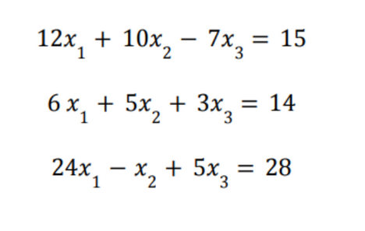
Q1) Using the above equations

i) Construct the A, x and b matrix from the above linear equation set
ii) Using the above equation, use Gaussian Elimination to find the solution of the system.

Q2) Using the above equations

i) By calculating the row multipliers, m, find A⁽²⁾
ii) Find F⁽²⁾ and A⁽³⁾
iii) Find L and U
iv) Find the solution of the system.

Chapter 7(Integration)

Q1) For the following equations with interval [-1,4], find:
- e^{5x} + 5x
- 6x - e^{-2x}
- 5x² + e^{-1x}
- sin(2x+3)
- cos(5x)

i) Actual integral value
ii) Evaluate n=1 (nodes =2) with closed Newton Cotes formulae (Trapezium Rule). Also find absolute and relative error.
iii) Evaluate n = 2 (nodes = 3) with closed Newton Cotes formulae( Simpson Rule). Also find absolute and relative error.
iv) Find approximate integral using Composite Newton Cotes formulae using C_{1,3} , C_{1,4} , C_{1,5} , C_{1,5} . Also find absolute and relative error for each case.

Chapter 6(Integration)

Q1) Consider a system where f(2)=5 , f(1)=9, f(7)=2, f(4)=0. Using this, find the best fit linear polynomial.
i) Show the values in equation format
ii) Find A, x and b
iii) Using the Gram-Schmidt process, find the orthonormal columns q1 and q2.
iv) Construct Q.
v) Find matrix R
vi) Find matrix x
vii) Find the best fit linear polynomial

Q2) Consider a system where f(2)=5 , f(1)=9, f(7)=2, f(4)=0. Using this, find the best fit quadratic polynomial (degree = 2).
i) Show the values in equation format
ii) Find A, x and b
iii) Using the Gram-Schmidt process, find the orthonormal columns q1 and q2.
iv) Construct Q.
v) Find matrix R
vi) Find matrix x
vii) Find the best fit linear polynomial

